**Lock Cart Web Portal**

*Author: Saurav Satpathy*

*Date: 18/11/2022*

This website is designed for Admin people. Where they can manage the application. It has mainly two roles Admin and Super admin. Admin can perform User, Device, and Ticket related operations, whereas super admin can perform only Company related operations. Before using the device in the trolly we need to register the device into the application.

**Tools & Technology**

* IDE: Visual Studio
* Technology: React JS (Frontend), Node JS(Backend)
* API testing tools: Postman
* Deployment: AWS
* Version controlling tools: GitHub

GitHub URL for the web module:

**Frontend:** <https://github.com/CartLock/CartLock-BE-test.git>

**Backend:** <https://github.com/CartLock/CartLock-BE-test.git>

**Note**

Both the front and backend are properly tested using postman as well from a user perspective.

The website can run on every browser like edge, chrome, safari etc.

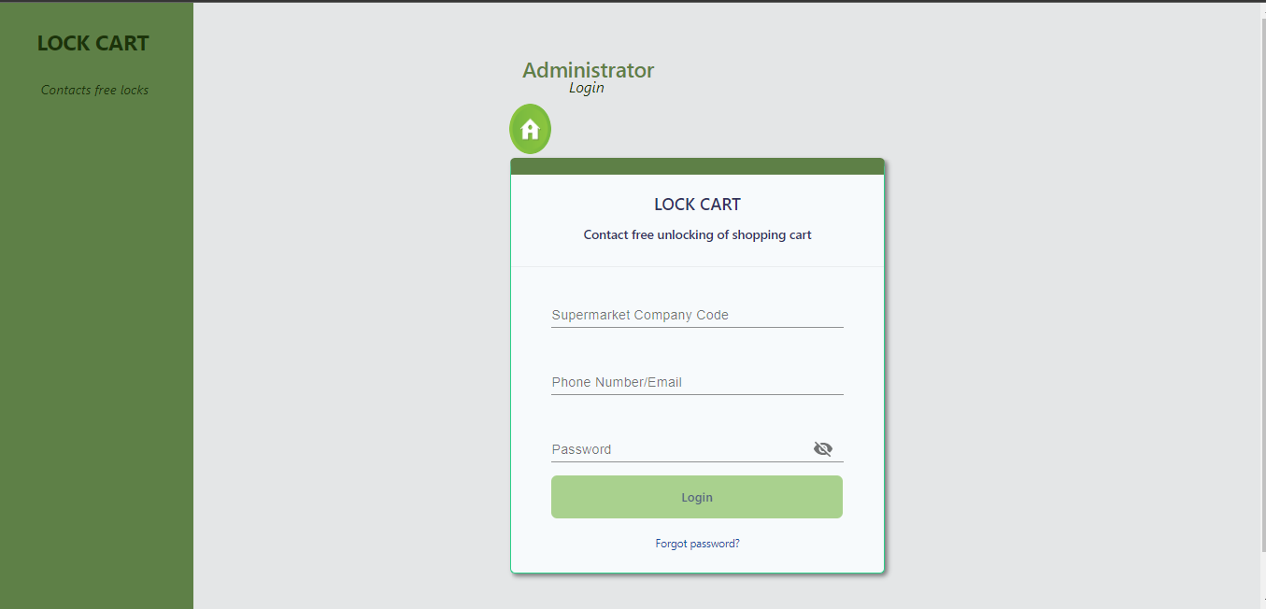

* It is a login module where a user can log in to the dashboard using the credential.
* Without proper credentials, it will give you an error.
* If the user forgot his/her credential then no worry, by clicking the Forgot password? he/she can reset the password.

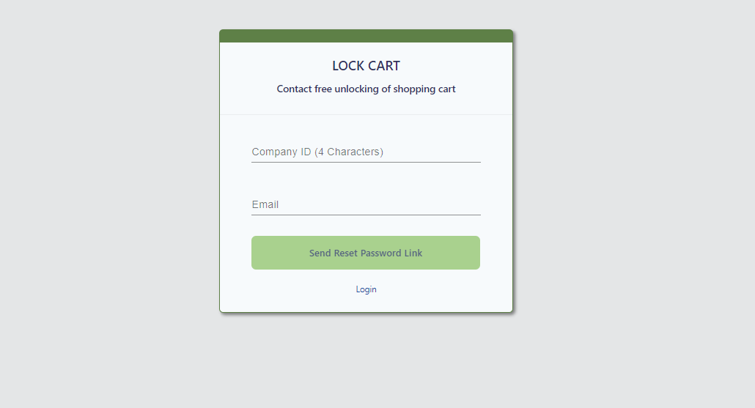

* Here is the forgot password page where the user needs to give the respected entry for resetting the password.
* Once the user presses the Sent Reset Password Link button then he/she will get the link to reset the password on the registered email.
* Simply click on the link and that will take you to the Reset Password page where you can change your password smoothly.

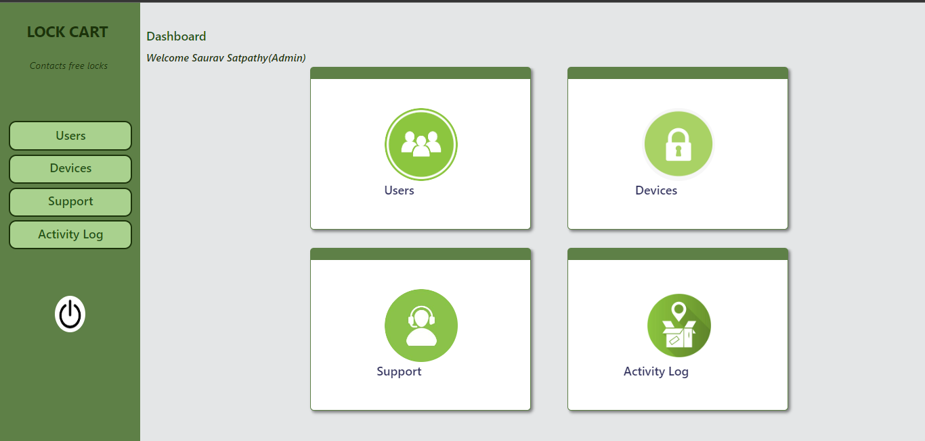

* Once you log in with your credential this page will appear which is called as admin Dashboard page.
* Here you can see and access all your modules which are provided by the application.
* By clicking on the left-side power button symbol you can log out yourself if you want to.

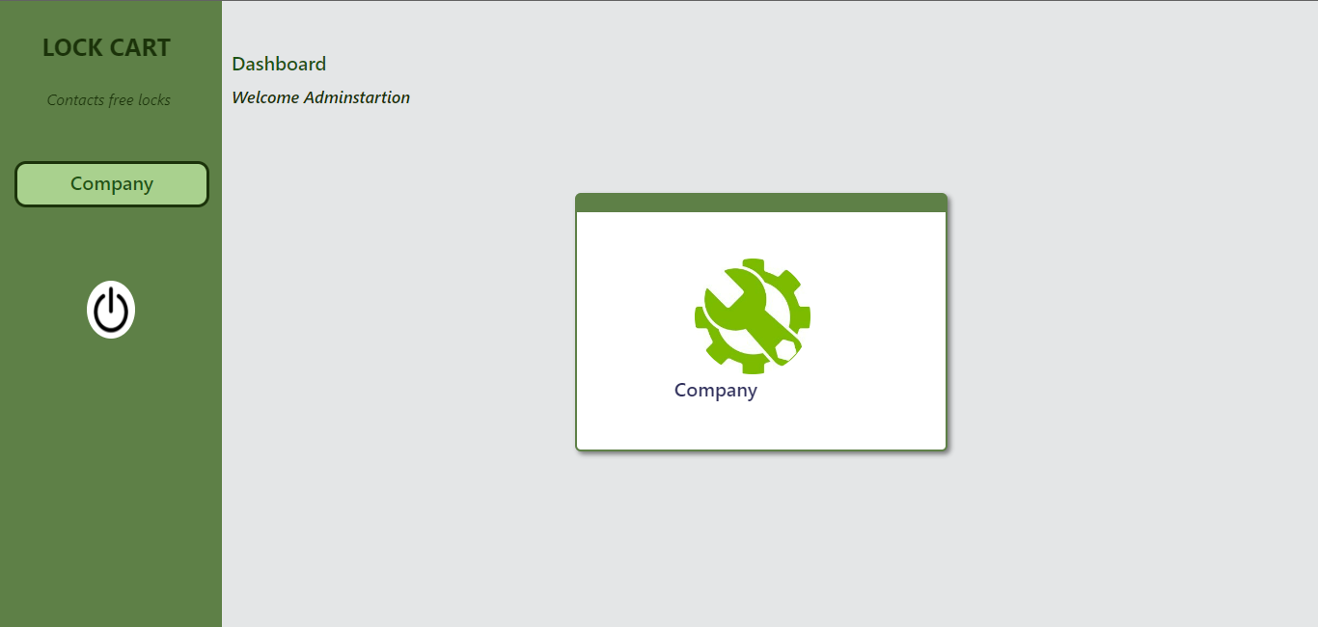

* It is the Super admin Dashboard page where you can work with only the Company Module.
* To Work with this, you need to log in with your super admin credential.
* Here you can do only following thing

**Add Company**

**Modify Company.**

**Add/ Modify Mailer Configuration**

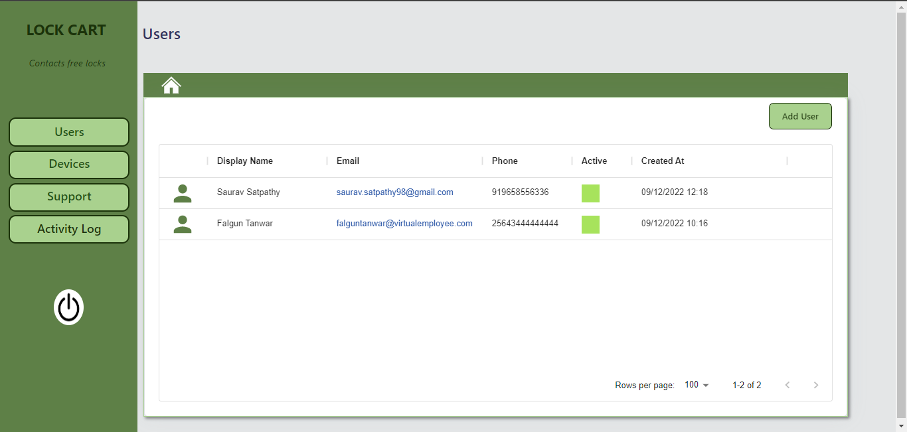

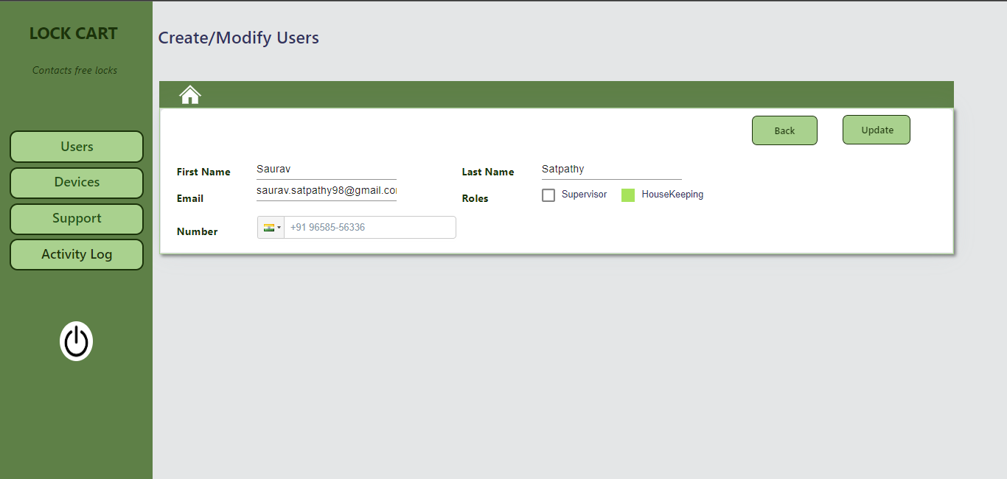

* It is the User Module where you add or update the Users.
* The user has two Roles (**Supervisor, Housekeeping).**
* While creating the Users you can only select any one role

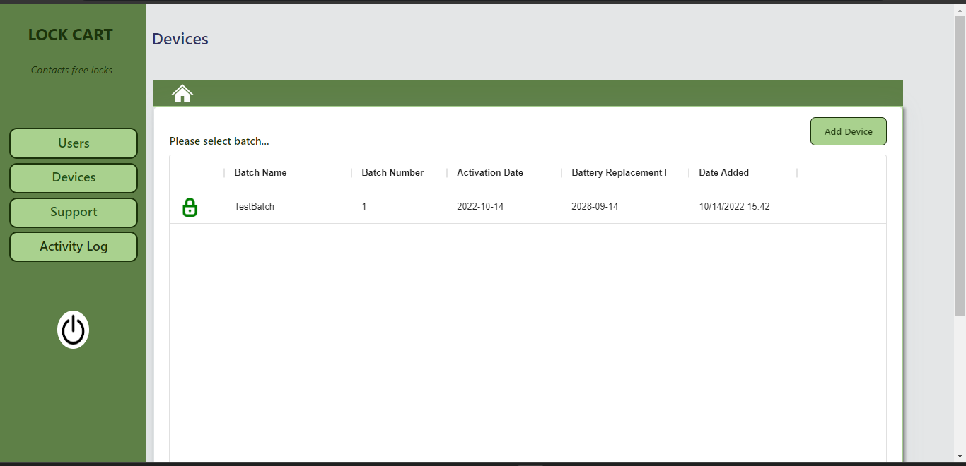

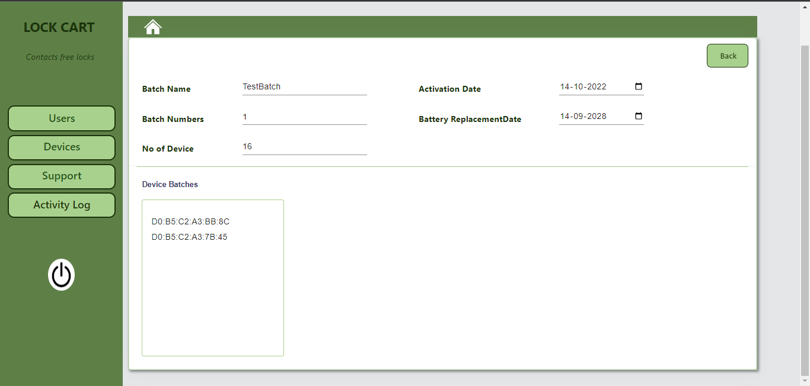

* Here is the Devie module. By using this you can register your device into the system
* To register the device, you only need the excel file.
* The file needs to contain the **MAC ADDRESS** of the device.

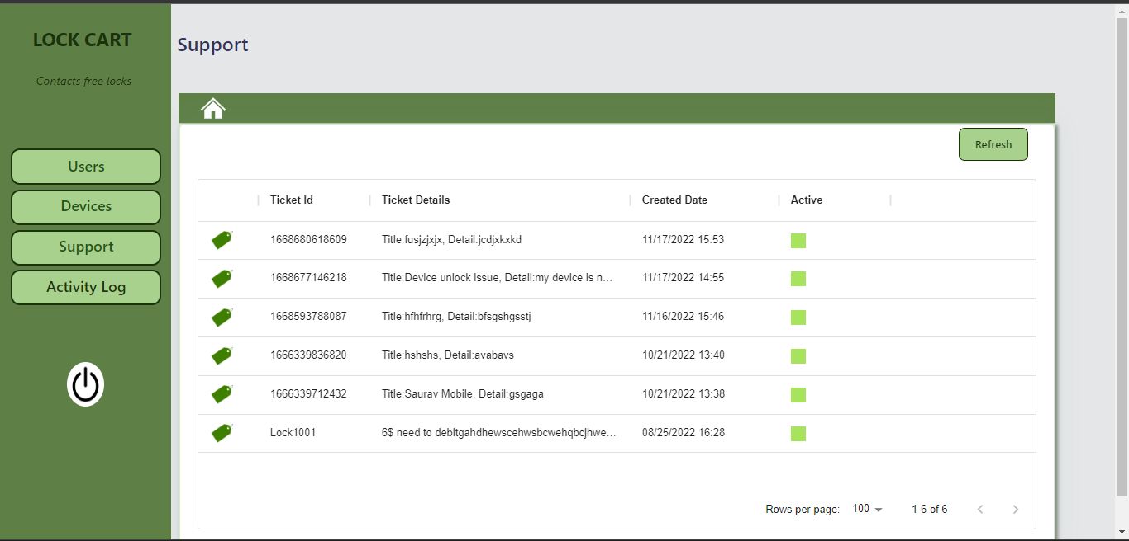

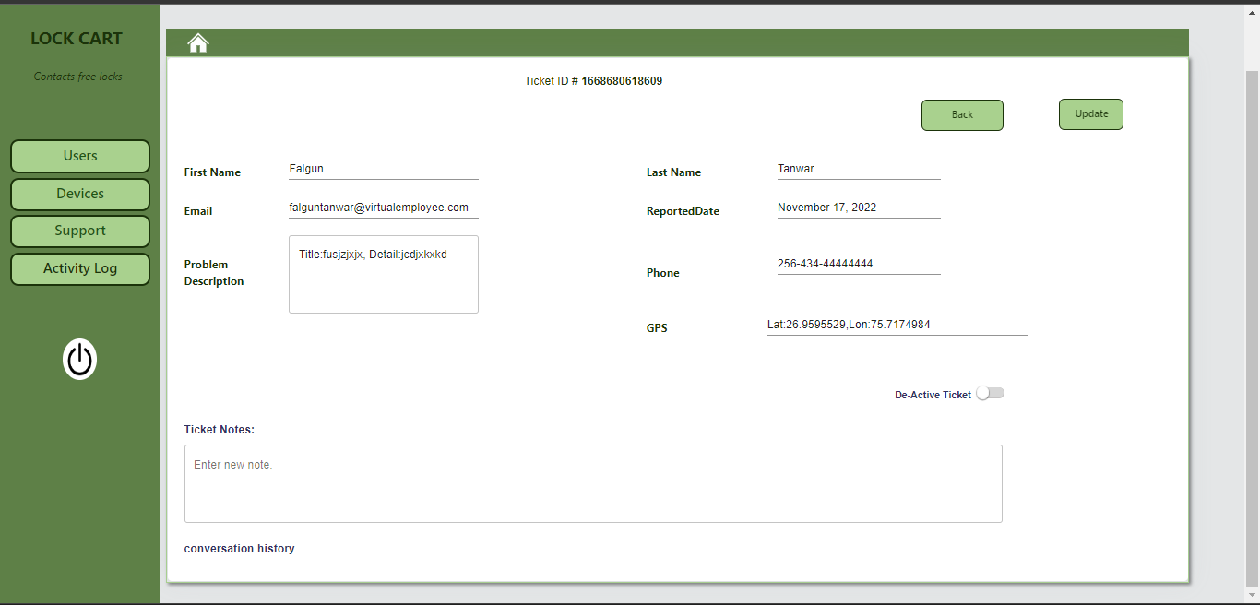

* It is the Support Page where you see the raised ticket from the mobile application and also you can modify them.
* If you want to close the ticket then press on the **De-Active Ticket** button to de-active it.
* Once it is de-active then it won’t appear on the list.

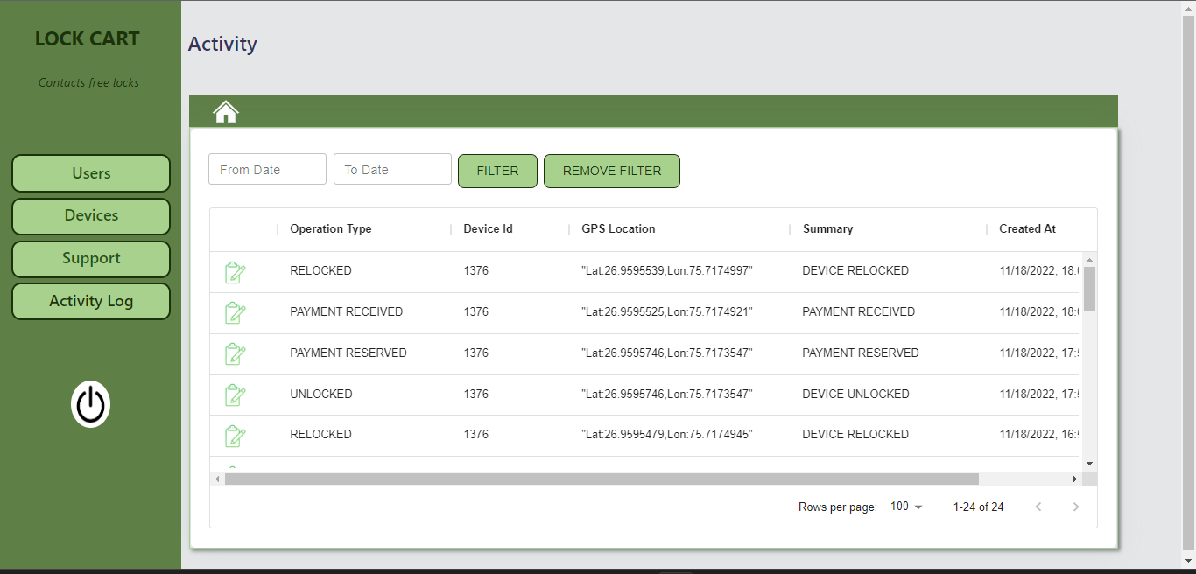

* Is the Activity Log page where you see the log which is created from the mobile application to track the device.
* You can also filter the log by using the Date Filter.

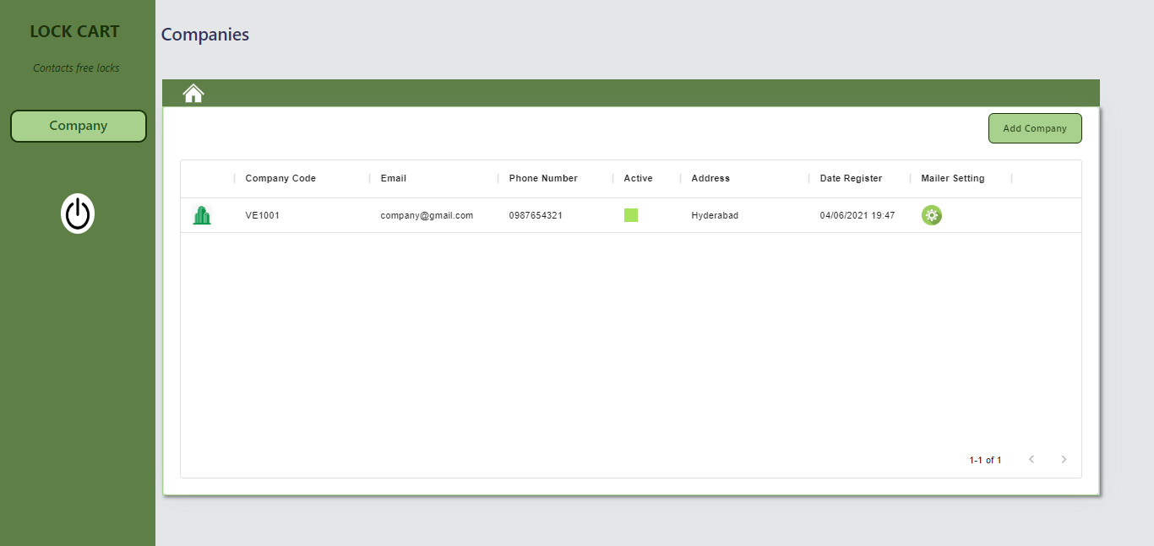

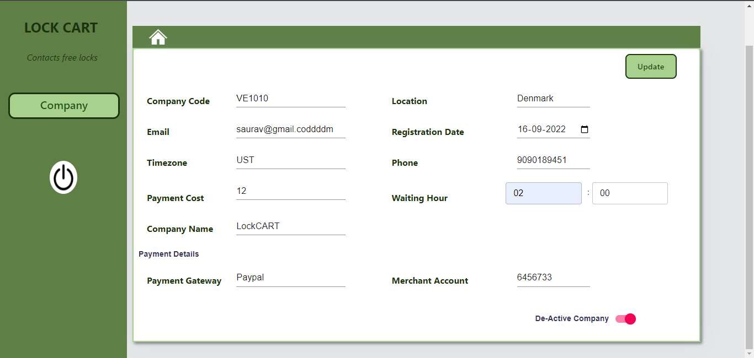

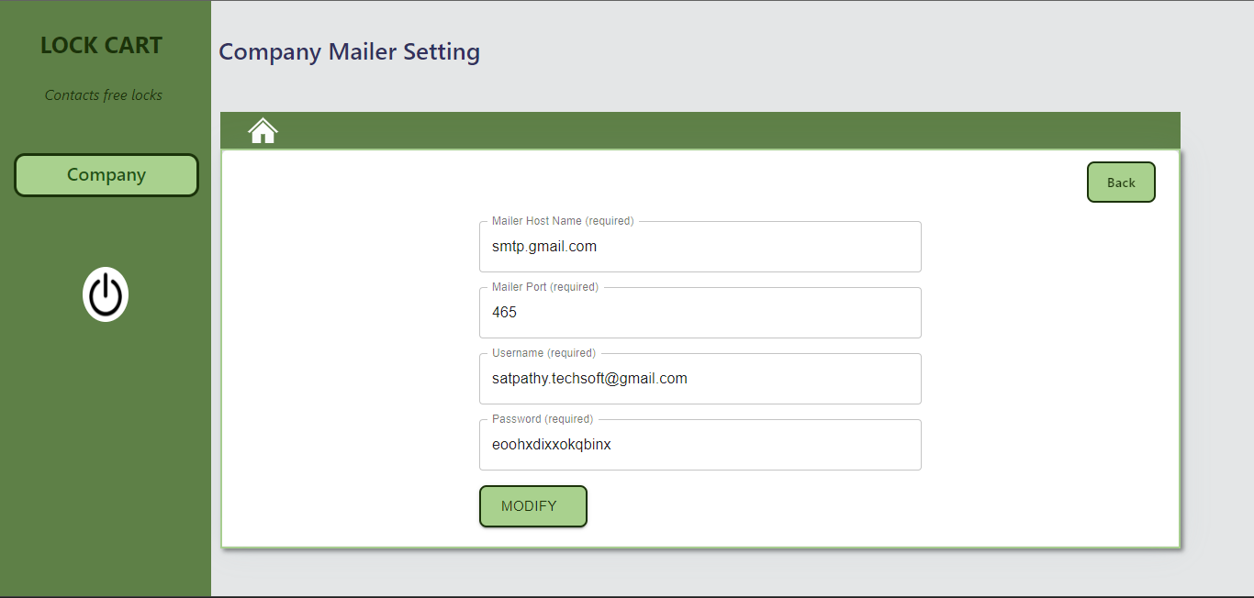

* The above page is related to the Super admin Company module. Where you Add, Modify Company, and Mailer Configuration.
* Mailer is basically SMTP details to send the email.